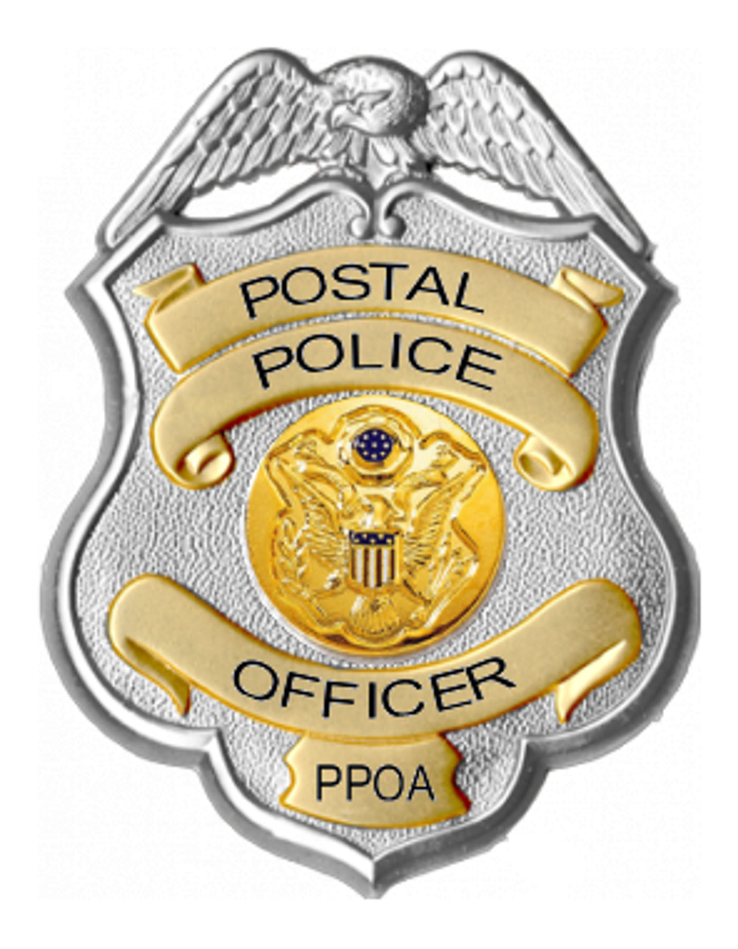
POSTAL POLICE
OFFICERS ASSOCIATION

2018 EXECUTIVE BOARD ELECTION NOMINATION NOTICE

NOMINATIONS WILL BE ACCEPTED BEGINNING FRIDAY JUNE 1, 2018 AND MUST BE RECEIVED NO LATER THAN FRIDAY JUNE 22, 2018

Nominations for the office of Area National Representative for the North Eastern, Eastern, Central, Southern, and Western Regions will be accepted during the nomination period from members-in-good-standing. Terms of office for the respective positions begin September 1, 2018 and end August 31, 2021.

ONLY MEMBERS-IN-GOOD-STANDING WILL BE PERMITTED TO NOMINATE CANDIDATES AND ACCEPT NOMINATIONS.

Members-in-good-standing are defined as those members who are current on their respective union dues as of May 1, 2018. Additionally, members who have lapsed in their dues as a result of medical leave or administrative/disciplinary action will be given the opportunity to bring their dues current and nominate/accept nominations, as long as such action occurs no later than Friday June 22, 2018. Self-nominations are permitted.

NOMINATIONS MUST BE RECEIVED IN THE PPOA’S SECRETARY-TREASURER P.O. BOX NO LATER THAN 5:00 P.M. (EST) ON FRIDAY, JUNE 22, 2018 TO BE ELIGIBLE OR EMAIL: ERICFREEMAN@PPOA.US

Nominations should be sent to Eric Freeman – National Secretary/Treasurer – PO Box 90311, Washington, DC 20090-0311. Email nominations are permitted at ericfreeman@ppoa.us.

ON MONDAY, JUNE 25, 2018, THE ELECTION COMMITTEE WILL REVIEW THE CURRENT MEMBERSHIP LIST TO ENSURE ELIGIBILITY COMPLIANCE.

The Election Committee Chairman will contact each nominee to confirm or dispel acceptance of the nomination. If accepted, nominees will be required to inform the PPOA Election Committee via email by Wednesday, June 27, 2018. Candidates will be provided a list of election and campaign rules, in addition to information regarding distribution of campaign literature.

ANY INQUIRIES REGARDING THE AFOREMENTIONED REQUIREMENTS OR PROCEDURES SHOULD BE DIRECTED TO THE ELECTION COMMITTEE CHAIRMAN – SECRETARY/TREASURER
ERIC FREEMAN AT: ERICFREEMAN@PPOA.US.

--------------------------------------------------------------------------------------------------------------------------------------------------------------------
NOMINATION FORM

NOMINATOR NAME: _________________________________________________________________________________________________________
NOMINATOR BEST CONTACT NUMBER: ________________________________________________________________________________________
NOMINEE NAME: ___________________________________________________________________________________________________________
NOMINEE DIVISION AND WORKSITE: __________________________________________________________________________________________
NOMINEE BEST CONTACT NUMBER: __________________________________________________________________________________________
NOMINEE EMAIL: ___________________________________________________________________________________________________________
POSITION NOMINATED FOR: _________________________________________________________________________________________________

Mail to: Eric Freeman or email: ericfreeman@ppoa.us
Election Committee Chairman
P.O. Box 90311
Washington, DC 20090-0311
Email nominations are permitted.
Nominations must be received by 5:00 p.m. (EST) on Friday, June 22, 2018

